**Experiment No : 5**

**AIM**

Familiarization of LINUX Commands.

**CO2**

Perform system administration task.

**Procedure**

1. read

command to accept single line of input

$ read

Output

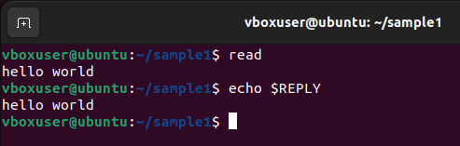

* 1. read [variable names]

to read contents of a line into variables.

$ read v1 v2 v3

Output

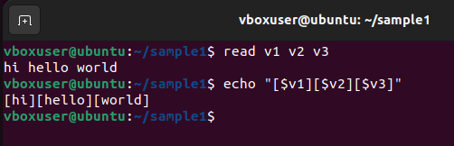

* 1. read –p [user command prompt]

to prompt user to enter values.

$ read –p “Enter your name”

Output

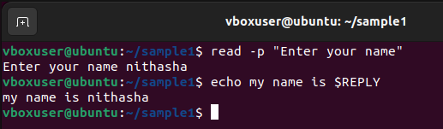

* 1. read –n [specified character limit] [user command prompt]

to prompt the user to enter values and is restricted to the character limit specified by user.

$ read in 5 “Enter 5 characters only “

Output

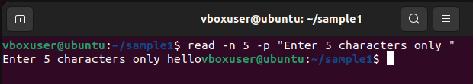

* 1. read –s –p [user command prompt]

to prompt user to enter values which is secured and invisible to the user.

$ read –s –p “Enter your password “

Output

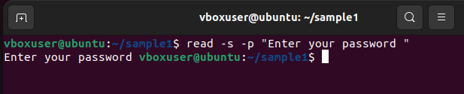

1. echo

to display the contents read by ‘$ read’ command.

$ echo $REPLY

Output



* 1. echo [variable names]

to print the values read by ‘read’ command.

$ echo “[$v1][$v2][$v3]”

Output



3) wc [filename]

To display number of lines, number of words, number of bytes and filename.

$wc file.txt

Output

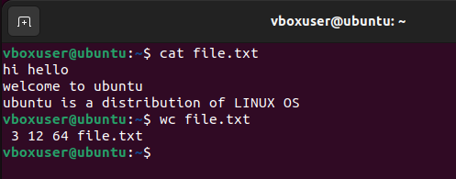

3.1) wc –l [filename]

Displays the number of lines.

$wc –l file.txt

Output

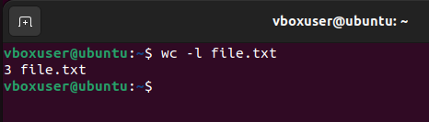

3.2) wc –m [filename]

Displays the number of characters/bytes.

$wc –m file.txt

Output

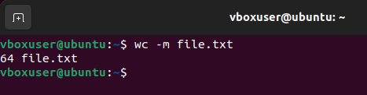

3.3) wc –w [filename]

Displays the number of words.

$wc –w file.txt

Output

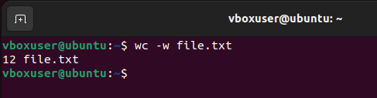

3.4) wc –L [filename]

Displays the length of longest word.

Output

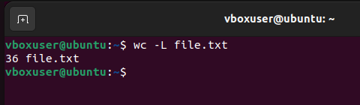

* 1. paste –d [delimiter] [sourcefile] [copyfile]

to copy and paste the contents of file 1 to file 2, separating them with specified delimiter.

$ paste –d ‘%’ samplef file.txt

Output

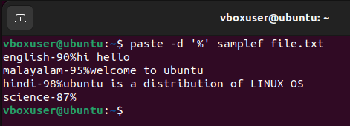

* 1. paste –d [delimiter] [filecontent1] [filecontent2] > [copyfile]

to copy and paste the contents of file 1,file 2 to file 3, with separating each file

content with specified delimiter.

$ paste –d ‘%’ samplef mark > mark1

Output

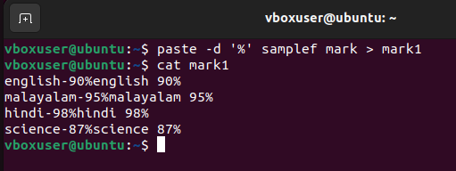

* 1. paste –s [filename]

to print the contents of file in single line.

$ paste –s

Output

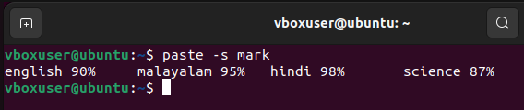

3) cp

to copy contents of a file to another file.

3.1) cp [sourcefile] [copyfile]

to copy contents of file1 to file2 by overwriting the contents of file2.

$ cp mark mark1

Output

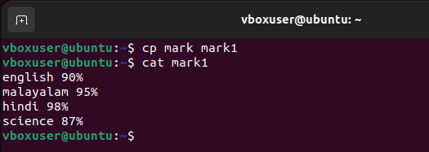

3.2) cp –r [source directory] [copy directory]

To copy the directory to another along with its subdirectory.

$ cp –r sample sample1

Output

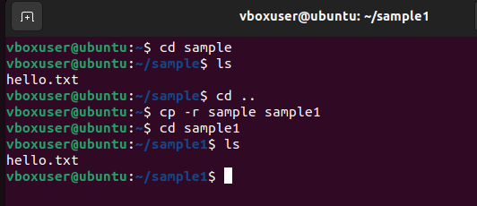

4) more [filename]

The more command is similar to cat to display the content. The only difference is that in case of large files, cat command output will scroll off your screen while more command display output one output screen at a time.

$ more samplefile.txt

Output

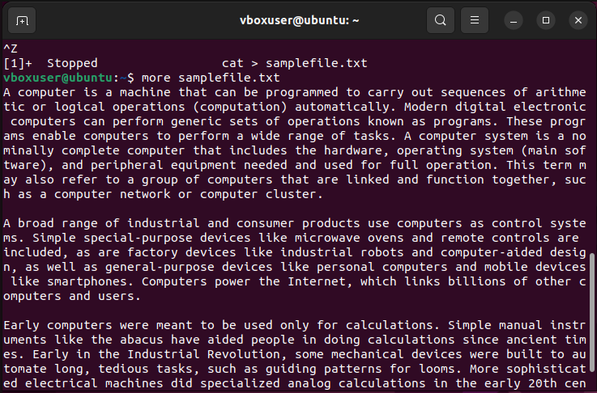

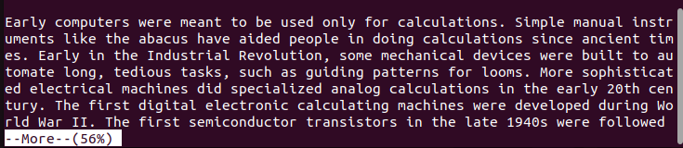

4.1) more +[specified number of lines] [filename]

To display the contents of file after specified number of lines.

$ more +5 samplefile.txt

Output

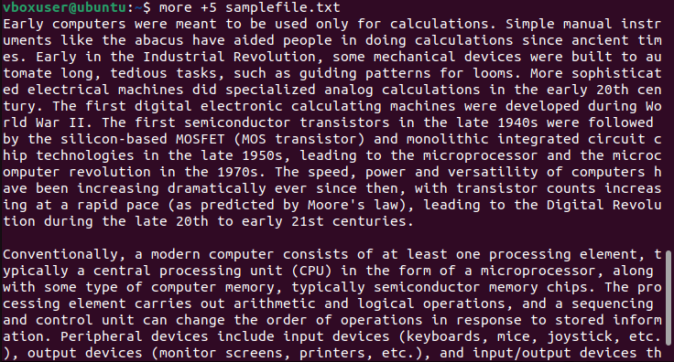

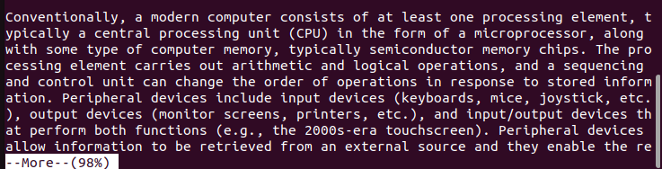

4.2) more +/[pattern] [filename]

This option is used to search the string inside your text document. You can view all the instances by navigating through the results.

$ more +/computer samplefile.txt

Output

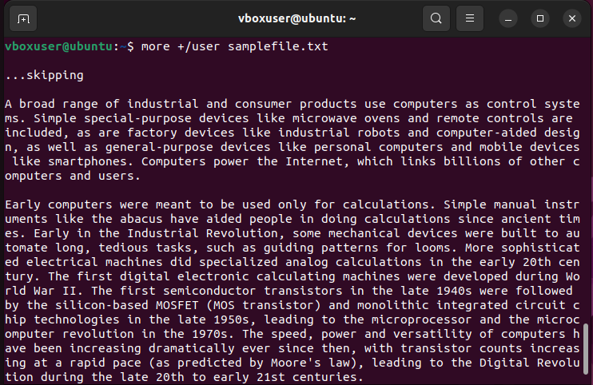



4.3) more –d [filename]

To help users to navigate through file according to the instruction. Displays “space to continue, ’q’ to quit”.

$more –d samplefile.txt

Output

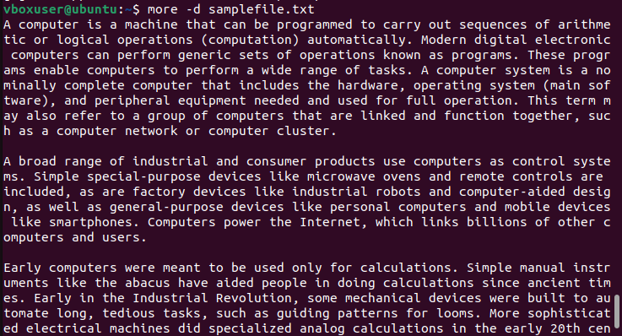

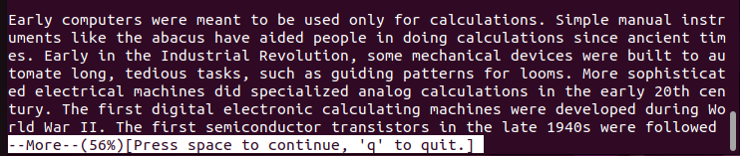

Result

The program has been executed and output has been verified.